A9G GPRS/GSM+GPS/BDS Module

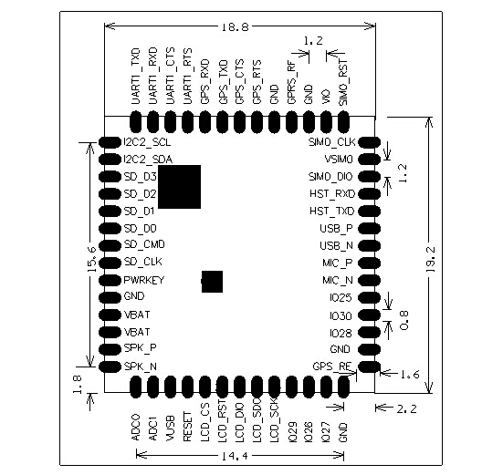

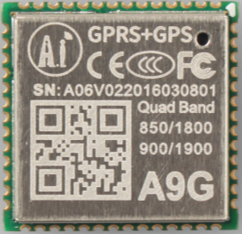

Overview
Features

The A9G is a complete quad-band GSM / GPRS module that combines GPRS and GPS / BDS technologies and integrates it in a compact SMD package, saving customers time and money in developing GNSS applications.
The A9G can be used in a wide range of IoT applications and is ideal for IoT applications for home automation, industrial wireless control, wearable electronics, wireless location sensing devices, wireless location system signals and other IoT applications.
A9G SMD package, through the standard SMT equipment to achieve rapid production of products, especially for automation, large-scale, low-cost modern production methods for the convenience of a variety of Internet of Things hardware terminal applications.

- Complete quad-band GSM / GPRS module, 800/900 / 1800 / 1900MHz
- SMD package for easy MP & testing
- Low power mode, average current 2mA or less
- support GPS, BD.
- Supports digital audio and analog audio, supports HR, FR, EFR, AMR voice coding
- Support voice calls and SMS messages
- Embedded network service protocol stack
- Support standard GSM07.07,07.05AT command and Anxin expandable command set
- Support PBCCH
- Supports firmware upgrade via serial port

Product specifications

Shenzhen Ai-Thinker Technology Co., Ltd
Address: 6/F, Block C2, Huafeng Industrial Park, Hangcheng Road, Bao'an Road, Baoan District, Shenzhen ,China
Website: www.ai-thinker.com Tel: 0755-29162996 E-mail: support@aithinker.com

Model Name | A9G
Package | SMD54
Size | 19.2*18.8*2.5(±0.2)mm
Frenquency | 850/900/1800/1900MHz
GPRS Multi-slot | Class 12
GPRS Mobile Station | Class B
Compatible with GSM Phase 2/2+ | Class 4 (2W@850/ 900MHz)  Class 1 (1W@1800/1900MHz)
Power supply | 3.5~4.2V typical value 4.0V
Current | 1.14mA@DRX=5  1.03mA@DRX=9
AT command | 3GPP TS 27.007, 27.005
GPRS Class 12 | Max 85.6kbps (up & down）
Coding scheme | CS 1,2, 3, 4
PBCCH | Support
Text | Point to point sms send and receive  Cellular broadcast message, Text / PDU mode
Voice coding mode | Half Rate (HR)、Full Rate (FR)、  Enhanced Full Rate (EFR)、  Adaptive Multi-Rate (AMR)
Audio processing mechanism | Echo Cancellation, Echo suppression, Noise suppression
SIM Card | 1.8V/3V
UART | 3 pcs ( including firmware upgrade serial port )， baud rate support 2400~1843200bps，default 115200bps
Antenna | Pad（include GSM、GPS）
Communication Interface | I2C、USB、UART、SDMMC、GPIO、ADC
GPS Sensitivity | Cold start: -148 dBm  Hot start: -162 dBm  Recapture: -164dBm  Tracking: -166 dBm
GPS boot time | Cold start < 27.5s  Hot start < 1s  Recapture < 1s
GPS accuracy | Horizontal positioning accuracy：2.5m  High positioning accuracy：3.5m
Working temperature | -20°C ~ +75°C
Weight | About 3.0g

Contact US

